Report Write Up

# Animated Time Plot for Camera Trap Data

## Purpose

The goal this project is to transform count data into a animated time plot to help visualize species density in a 24hr time frame throughout seasons. The data is collected over a period of three years from camera traps collected at Degrasse, Kip tract, Donnerville, Lampson, Donnerville (Ash), Lampson Falls, ELB, Peavine, Kip, and South Hammond. The ecology of these locations are comprised of deciduous forestry, wetlands (and their derivatives), agricultural fields, and developments. These locations are chosen to give a fair representation of the North Country. The collection method is camera trap which is comprised of a motion detector camera mounted to a solid structure. The operations of these camera traps samplers are to take a picture of anything that passes in front of the motion detector. The data is then collected and analyzed by volunteers who mark the date, time, and species type captured within the photograph; making sure to remove any duplicates or empty pictures taken by the camera traps. The information is then uploaded to the provided data frame.

library(tidyverse)

── Attaching core tidyverse packages ──────────────────────── tidyverse 2.0.0 ──  
✔ dplyr 1.1.4 ✔ readr 2.1.4  
✔ forcats 1.0.0 ✔ stringr 1.5.1  
✔ ggplot2 3.4.4 ✔ tibble 3.2.1  
✔ lubridate 1.9.3 ✔ tidyr 1.3.0  
✔ purrr 1.0.2   
── Conflicts ────────────────────────────────────────── tidyverse_conflicts() ──  
✖ dplyr::filter() masks stats::filter()  
✖ dplyr::lag() masks stats::lag()  
ℹ Use the conflicted package (<http://conflicted.r-lib.org/>) to force all conflicts to become errors

library(overlap)

This is overlap devel version 0.3.4.1.  
For overview type ?overlap; for changes do news(p='overlap').

library(here)

here() starts at /Users/buzz/Desktop/STAT-313_Rstudio/STAT_Honors_Project_F23

library(lubridate)  
library(gganimate)  
library(transformr)

*{r webshot, echo=FALSE, cache=TRUE, screenshot.opts=list(delay=3), fig.width=15, fig.cap="Click image to open website."} if(is.null(webshot:::find_phantom())) webshot::install_phantomjs() knitr::include_app('https://natureupnorth.shinyapps.io/NoCoWildShinyApp/') * <https://natureupnorth.shinyapps.io/NoCoWildShinyApp/>

This project was inspired both by a interest in environmental studies and the substance of the website above. Created in 2020 by honors student Kate Andy the website details information from the North Country Wild Project, a culmination of information detailing the density, distribution, and richness of wildlife found in the North Country area. In the website there can be found simple bar charts detailing count of species and distribution of total sightings described in a 24 hour plot. The shortcomings of these plots and ultimately the foundation of this honors project is the representation of distribution over time.

## Data explotation

camera_df <- read_csv(here("data/camera_trap.csv"))

New names:  
Rows: 2127 Columns: 9  
── Column specification  
──────────────────────────────────────────────────────── Delimiter: "," chr  
(6): Img1, Img2, Img3, Forest, DTO, choice dbl (3): ...1, subject_ids,  
subject_set_id  
ℹ Use `spec()` to retrieve the full column specification for this data. ℹ  
Specify the column types or set `show_col_types = FALSE` to quiet this message.  
• `` -> `...1`

The data set is comprised of 2127 cases, each case represents an individual observation. The variables that detail each case are as such; …1 is the relative index number for each case in this data set. Subject_ids, is the absolute index number for each photo. Img1 – img3, are the three JPG references for each photo. Forest is the location at which the camera trap was placed and the subsequent photo was taken. DTO is the date (given in month/day/year) and time (given in hour: minute) at which the photo was taken. Subject_set_id indexes the three distinct periods in which the data was collected and uploaded to the data frame (103437 for periods 7/3/21 to 12/4/21) (108373 for periods 7/3/21 to 12/4/21) (112935 for period 2/3/23 to 4/1/23). Choice a categorical variable which describes the specific species that was captured within the given photograph. The specific observed species are as such; marten, beaver, black bear, blue Jay, rabbit, coyote, raven, dog, fisher, grey fox, red fox, wild goose, grouse ruffed, mink, mole, mountain loin, opossum, other domestic live stock, owl, porcupine reptile or Amphibian, river otter, snow shoe hare, flying squirrel, red squirrel, turkey, weasel, woodchuck, chipmunk, white tailed deer, other birds, other small mammal, raccoon, and gray squirrel.

After evaluation of the data and its sampling methods we find some constraints. Count traps can be very beneficial and very limited, the benefit of a camera trap is one can plant the device and walk away a sampling of convenience. The limitation of this device is perception as the device only takes a picture when a subject moves within the range of its visibility which is approximately 90° and a maximum of 80-100 feet. Given the confined range of sight any subject not within view of that range will not be recorded even if it is present in the area. For reasons of sampling the camera traps are also only present five months out of the year. Additionally the data only goes up until 4/1/23, though the camera traps are still present to date the data has only been analyzed up to that date.

table(camera_df$choice) |> knitr::kable()

| Var1 | Freq |
| --- | --- |
| AMERICANPINEMARTEN | 1 |
| BEAVER | 2 |
| BLACKBEAR | 27 |
| BLUEJAY | 12 |
| CHIPMUNK | 111 |
| COTTONTAILRABBIT | 31 |
| COYOTE | 25 |
| CROWORRAVEN | 1 |
| DEERWHITETAILED | 532 |
| DOMESTICDOG | 25 |
| FISHER | 4 |
| FOXGRAY | 4 |
| FOXRED | 8 |
| GOOSEWILD | 1 |
| GROUSERUFFED | 5 |
| MINK | 1 |
| MOLE | 3 |
| MOUNTAINLION | 1 |
| OPOSSUM | 3 |
| OTHERBIRD | 131 |
| OTHERDOMESTICSTOCK | 2 |
| OTHERSMALLMAMMAL | 303 |
| OWL | 1 |
| PORCUPINE | 2 |
| RACCOON | 259 |
| REPTILEORAMPHIBIAN | 2 |
| RIVEROTTER | 1 |
| SNOWSHOEHARE | 4 |
| SQUIRRELFLYING | 3 |
| SQUIRRELGRAY | 539 |
| SQUIRRELRED | 52 |
| TURKEY | 29 |
| WEASEL | 1 |
| WOODCHUCK | 1 |

Above is a table of count for each species captured. In it we find the final constraint for this project. Much of the species only have counts ranging from 1 to 30 which for is too limited for longitudinal density plotting. Therefore for the purposes of this project we will specifically focus on Raccoon (259), Grey Squirrel (539), and white tail deer (532) for obsevation.

## Overlap

library(overlap)  
library(lubridate)  
  
## Convert 0:00 to 23:59 => 0 to 0.99  
## https://stackoverflow.com/questions/67613393/convert-time-to-fraction-of-a-day-fraction-of-a-week-and-fraction-of-a-month-in  
camera_df2 <- camera_df |> mutate(time = mdy_hm(DTO),   
 frac_day = ((hour(time)*60 + minute(time))/60)/24,  
 frac_week = (lubridate::wday(time, week_start = 1) - 1 + frac_day)/7,   
 frac_month = (day(time) - 1 + frac_day)/days_in_month(time),  
 time = round(frac_day,3),  
 week = round(frac_week,3),  
 month = round(frac_month,3),)  
  
range(camera_df2$time)

[1] 0.000 0.999

## Convert radians to degrees  
timeRad <- camera_df2$time * 2 * pi  
  
## Fitting kernel density  
deer <- timeRad[camera_df2$choice == 'DEERWHITETAILED']  
  
densityPlot(deer, rug=TRUE)

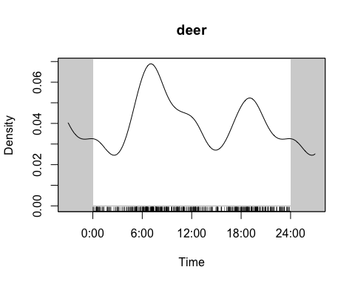

# where are my tick marks  
  
squirrel_g <- timeRad[camera_df2$choice == 'SQUIRRELGRAY']  
# compare distributions of different species  
  
# compare predictor and prey  
pp <- overlapEst(deer, squirrel_g, type="Dhat4")  
pp

Dhat4   
0.7352417

overlapPlot(deer, squirrel_g)  
legend('topright', c("DEERWHITETAILED", "SQUIRRELGRAY"), lty=c(1,2), col=c(1,4), bty='n')

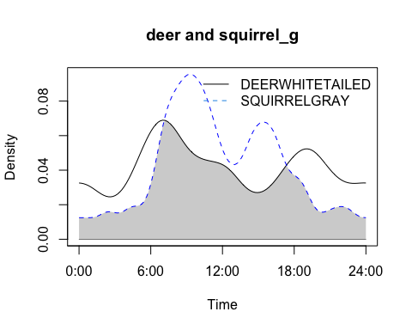

## Function

without_date <- camera_df   
get_interval_data <- function(date_choice, animal,  
 plus_minus) {  
 interval_df <- camera_df |>   
 mutate(time = mdy_hm(DTO),   
 frac_day = ((hour(time) * 60 + minute(time)) / 60) / 24,  
 frac_week = (lubridate::wday(time, week_start = 1) - 1 + frac_day) / 7,   
 frac_month = (day(time) - 1 + frac_day) / days_in_month(time),  
 time_of_day = round(frac_day, 3),  
 week = round(frac_week, 3),  
 month = round(frac_month, 3)) |>  
 mutate(day_of_year = yday(time)) |>  
 filter(day_of_year >= yday(ymd(date_choice)) - plus_minus &  
 day_of_year <= yday(ymd(date_choice)) + plus_minus) |>  
 filter(choice == animal) |>  
 mutate(timeRad = time_of_day * 2 * pi) |>  
 filter(year(time) != 2024) |> ## filter out 2024 data  
 select(time, day_of_year, everything())  
   
 plot_obj <- densityPlot(interval_df$timeRad, rug = TRUE) |>  
 mutate(date_choice = date_choice,  
 n_obs = nrow(interval_df))  
   
 rug_obj <- interval_df |> select(time) |>  
 mutate(date_choice = date_choice)  
   
 return(list(plot_obj, rug_obj))  
}  
  
date_vec <- seq(ymd('2010-07-15'), ymd('2010-12-15'), by = "days")  
# Look at day and month as these are

## Output (plot)

* SQUIRRELGRAY centered at 2022-08-28 with 30 day window.

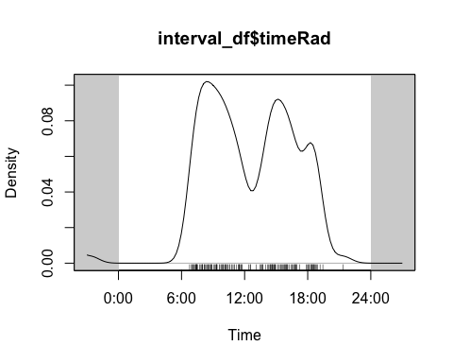

## Plot (gganimate)

## six

Overlap (site) Emphizis method is specia -> smooth zeros hour 24 to hour 0 ensure connection Study site description

Table of variables

explain plot *use ggplot

## Animation (Squirrel)



## Animation (Raccoon)

Final_Plot_Base_robber <- anim_base_robber + transition_time(date_choice) +  
 labs(title = "Month-Day: {format(frame_time, '%m-%d')}") +  
 shadow_mark(colour = "black", linewidth = 0.25, alpha = 0.15,  
 exclude_layer = 2)  
Final_Plot_Base_robber



## Animation (Raccoon 60 days)

Final_Plot_Base_robber_30 <- anim_base_robber_30 + transition_time(date_choice) +  
 labs(title = "Month-Day: {format(frame_time, '%m-%d')}") +  
 shadow_mark(colour = "black", linewidth = 0.25, alpha = 0.15,  
 exclude_layer = 2)  
Final_Plot_Base_robber_30



## Animation (deer)

Final_Plot_Base <- anim_base + transition_time(date_choice) +  
 labs(title = "Month-Day: {format(frame_time, '%m-%d')}") +  
 shadow_mark(colour = "black", linewidth = 0.25, alpha = 0.15,  
 exclude_layer = 2)  
Final_Plot_Base



Final_Plot_circle <- anim_circle + transition_time(date_choice) +  
 labs(title = "Month-Day: {format(frame_time, '%m-%d')}") +  
 shadow_mark(colour = "black", linewidth = 0.25, alpha = 0.15,  
 exclude_layer = 2)  
Final_Plot_circle



## Circular Animation (deer)

Final_Plot_circle <- anim_circle + transition_time(date_choice) +  
 labs(title = "Month-Day: {format(frame_time, '%m-%d')}") +  
 shadow_mark(colour = "black", linewidth = 0.25, alpha = 0.15,  
 exclude_layer = 2)  
Final_Plot_circle



## Thank you Dr. Erika barthelmess & Dr. Matt Higham